Exit

If the user selects “Exit” from the “Main Menu”, the following options will be presented.

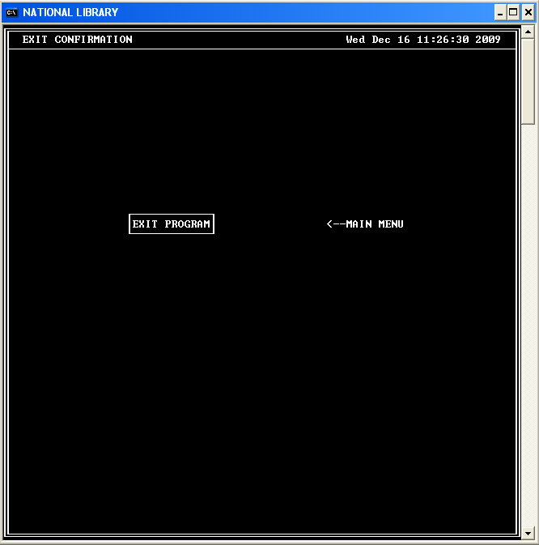

“EXIT PROGRAM” will end the program and “MAIN MENU” will take the user back to the “Main Menu”.

